GEECC Activity Instructions
Computer Science

Sphero Bolt Introduction (round robots, early morning activity)
- Form groups of two to three.
- Navigate to https://github.com/GSU-CS-Dept/EEA-Robot-Code/ in a web browser (Google Chrome is recommended).
- Open the GEECC CS Instructions – Sphero Bolt.pdf file.
- Retrieve a Sphero Bolt, a charging cradle, and the connected cable.
- Plug the cable into a computer.
- Place the cradle and the robot on top of the computer.
- Download the Sphero EDU app on either Android or iPhone and open the app after installation is complete.
- Open the Sphero EDU app, then click the top right icon. We need to connect to our Bolt to be able to program it.
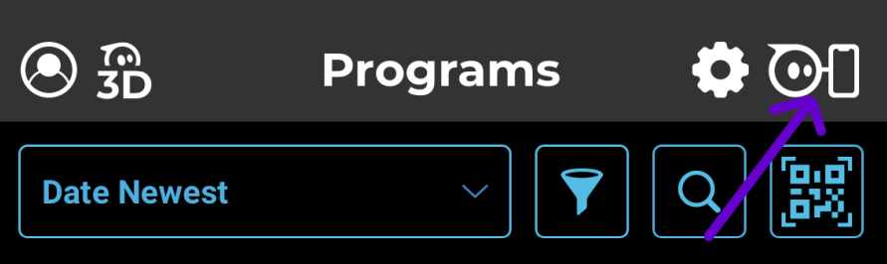
- Choose the Bolt, not the Bolt+.
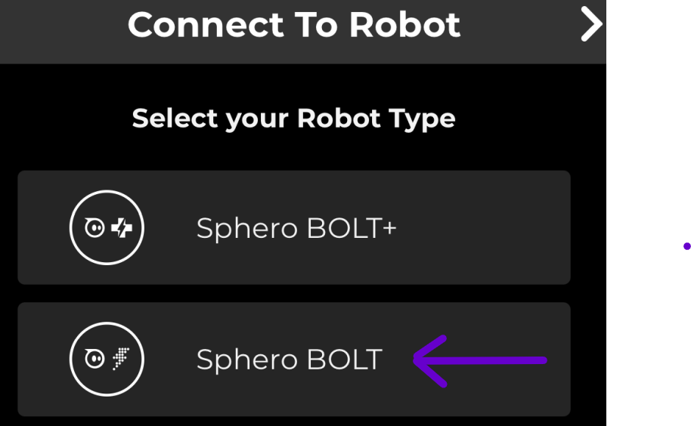
- Place your phone close to your Bolt and choose the one with the highest signal strength. You will see some connection confirmations. Your Bolt may also display a pattern to help you locate it.
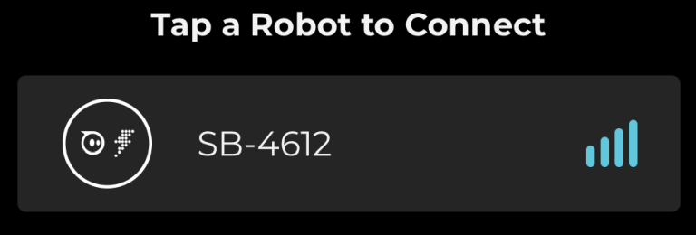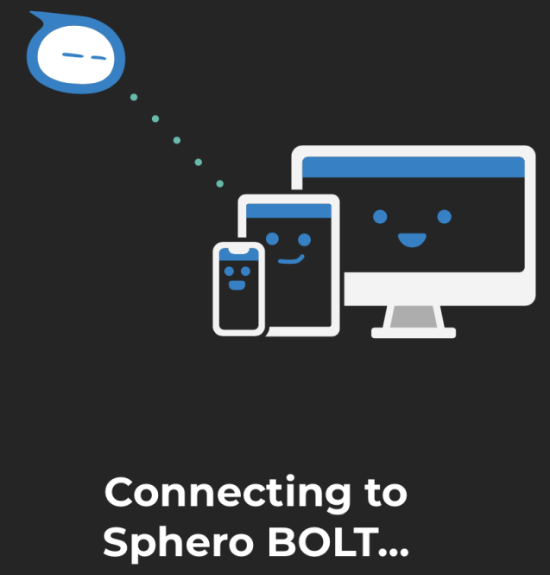
- Tap on “Drive” in the bottom right corner.
- Change the color using the top circle in the app so you can easily identify your robot.
- Tap on “Aim” and use the app to “aim” the robot in the correct forward direction.

- Once it is aimed, play around with free-driving the robot. What are some challenges? Does the driving behave the way you would expect? Is it easy to get used to the controls?
- Attempt to remote control the robot through an obstacle course.
Move to next section only after being instructed.

Sphero Bolt Simple Block Programming (mid-morning activity)
- In the Sphero EDU app, click on Create Program. Take the offered tour, it will help you get oriented with basic block programming. Give your program a name.
- Place the Bolt on the floor (outside the classroom may be easier). You can use the Aim button next to Start to make sure you are connected to the correct Bolt.
- Click the light icon to change the color of your LED to something different than the default. This will help you identify your robot.
- Start experimenting with different code blocks to try to navigate the robot around without human intervention. Play around with the code until your robot can navigate the course. Tap on any numerical values to change them or drag new code actions from the bottom bar based on category.
- Hit Start at the top to start executing code, Stop to stop the code executing.
Move to next section only after being instructed.

Sphero Bolt Programming with Bluetooth (late morning activity)
- Insert the provided Bluetooth USB adapter into your computer.
- Open the Google Chrome web browser. This will not work in other browsers.
- Navigate to https://edu.sphero.com/code in the Google Chrome web browser.
- Click on Connect.
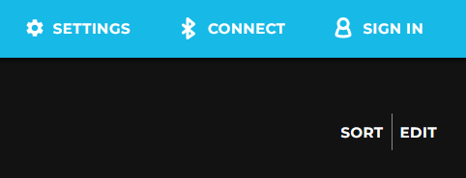
- Make sure to choose the Sphero Bolt, not the Bolt+.
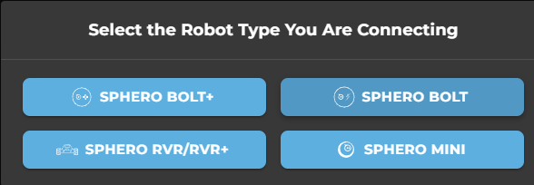

- Move to next page.
- Click Connect
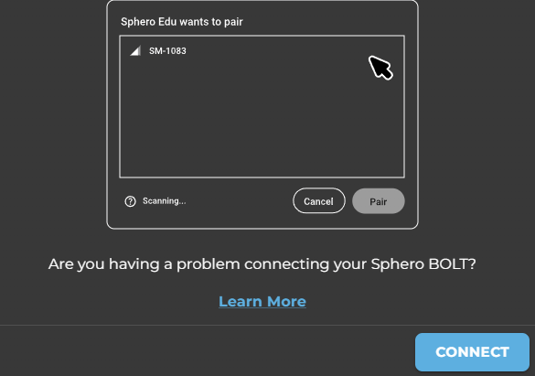
- Connect to your Sphero Bolt (check your robot’s display for the 4-digit number).
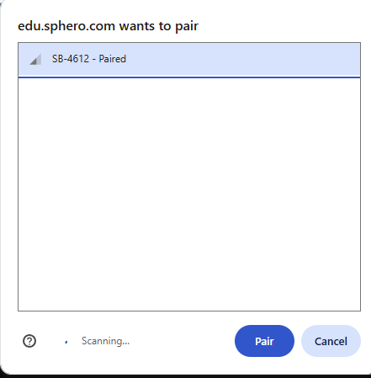
- Move to next page.

- Click on Create Program
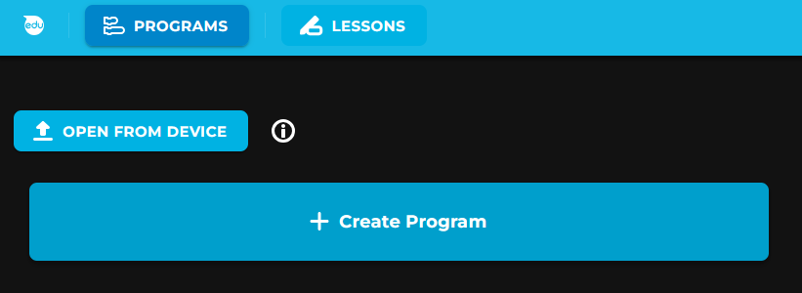
- Give your program a name and make sure the chosen options match the following screenshot (see next page), then click Create.
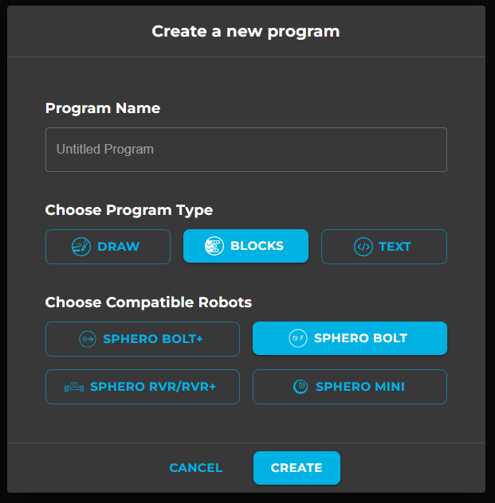
- Along the bottom of the page are various actions you can do on the bot. For each section, if you click on the left/right arrows, you can see all available actions. Either use the tilt function of the mouse’s scroll wheel to scroll through all available options or hold down the Shift key and scroll the mouse wheel up or down.
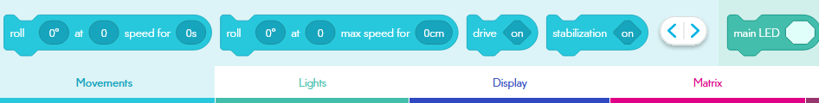
- Move to next page.

- You can drag those items onto the “on start program” section like a puzzle piece, then choose options by clicking on each available section (see next page). This can be done visually by clicking on the image, or by keyboard by clicking on the number first which will bring up a number pad (see next page).
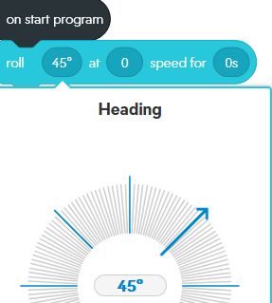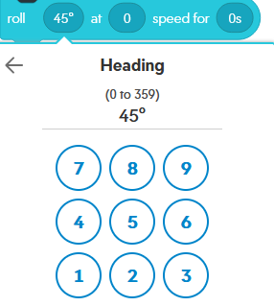
- If you need to delete any blocks, grab them and drag them to the bottom of the screen then click the trash can.
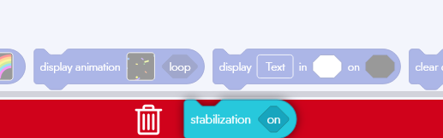
- Navigate to https://sites.google.com/sphero.com/sphero-edu-javascript-wiki in a web browser to see explanations for all of the possible actions available to each robot. Use the top header to find examples of each block available to you.
- When you are ready to run your program, place the Sphero Bolt on the ground, then click the Start button on the Sphero Edu website.

Move to next section only after being instructed.

Sphero Bolt Advanced Programming (afternoon activity)
- Ensure that you are still connected to your Bolt over Bluetooth.
- Navigate to https://edu.sphero.com/code in the Google Chrome web browser.
- Click on Create Program

- Give your program a name and make sure the chosen options match the following screenshot (see next page), then click Create. It does not matter whether you choose Python or JavaScript until we start providing code for the robot to run. Make sure to remember which one you chose!
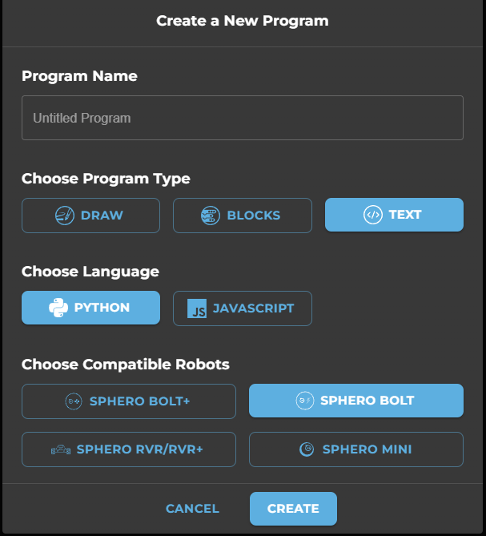
- When you were doing the block programming, you might have noticed that there were JavaScript and Python examples included that did similar things to the block programming actions. We will now use those items to program our robot directly.
- If you closed the website, reopen the https://sites.google.com/sphero.com/sphero-edu-javascript-wiki link.
- On the previous link, look for the “Hello, World” example. This is the most important program you will write in any programming language.
- Type the listed code for your chosen language (JavaScript will be easier to use). Do not copy/paste it, especially if using Python. Make sure that the spacing and indentation matches the example exactly!
- If you started with Python but are seeing issues under the “Problems” section, you can convert existing code to JavaScript. Use that option if you are having issues.
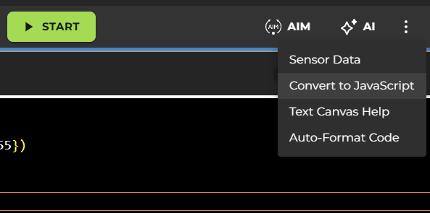
- Explore all of the options you have for programmed items and try to build a program that allows the bolt to perform some action. Those actions could include:
  - Navigating from a start point to an end point
  - Completing an obstacle course with no human intervention
  - Complete some kind of showy dance with colors and coordinated movements
    - This could also be done with another group
  - Perform any automated actions that could not be done easily in a manual controlled mode

